Name: Sanika Botre PRN: 25070122063
Batch: 2025-29 Branch: CSE A-2
Subject: Programming with Java

ASSIGNMENT No: 6

TITLE : Write a Java program to demonstrate the use of an inner class, an anonymous class.

Problem Statement: Write a Java program to demonstrate the use of an inner class, an anonymous class.

Learning Objectives: To implement inner classes and anonymous classes for improving encapsulation and event handling in Java.

Theory:

An inner class is a class defined inside another class and has access to all members of the enclosing class, including private members. Inner classes help improve code organization and logical grouping of related classes. Anonymous classes are unnamed inner classes that are instantiated only once and are mainly used for implementing interfaces or abstract classes. They simplify code by eliminating the need for separate class definitions. These concepts are widely used in Java GUI programming and event handling

Exercise:

1. Create a Vehicle program where an inner class displays vehicle details and anonymous class performs an action.

Code:-

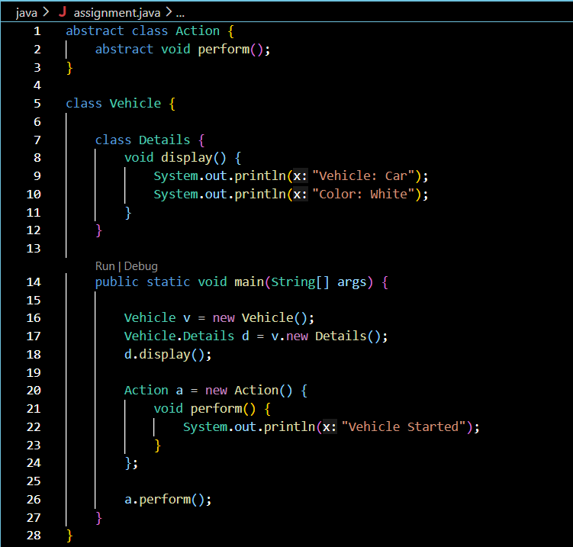

Output:-

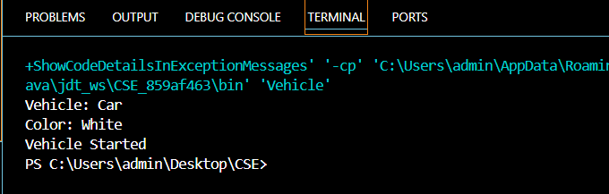

2. Develop a Food Delivery Application where an inner class handles order details and anonymous classes handle delivery status updates.

Code:-

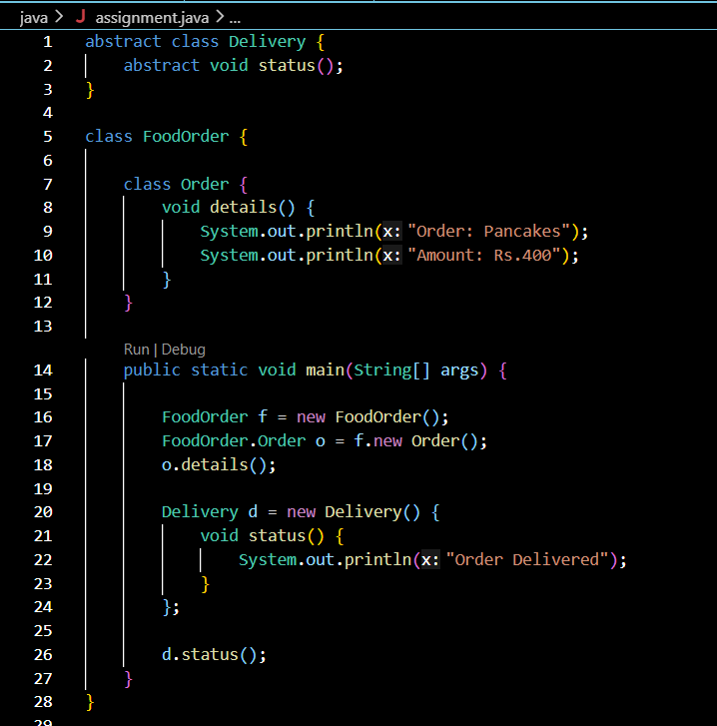

Output:-

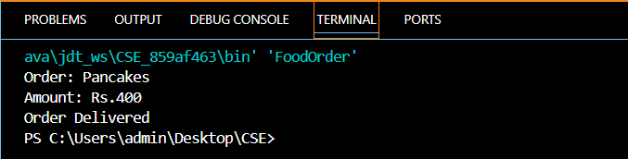

Conclusion:

This assignment successfully demonstrated the use of inner classes and anonymous classes in Java. The programs showed how inner classes help organize related functionality within a class, while anonymous classes provide a simple way to implement one-time functionality without creating a separate class. The implementation improved code readability and flexibility. Overall, this assignment enhanced the understanding of advanced class concepts and object-oriented programming in Java.

